COUNTRY DELIGHT SOCIAL MEDIA ANALYZING



**TARGETED AUDIENCE- Urban consumers seeking doorstep delivery of fresh, natural, and pure dairy products are the target market for Country Delight products. Customers may order, alter, and cancel their subscriptions through an app, which Country Delight hopes will make their service easy and convenient.**

**SOCIAL MEDIA PRESENCE-**

* **FOLLOWERS- 82.7K**
* **ENGAGEMENT- 0.16%**
* **NUMBER OF POSTS- 678**
* **POST PER DAY- 1**

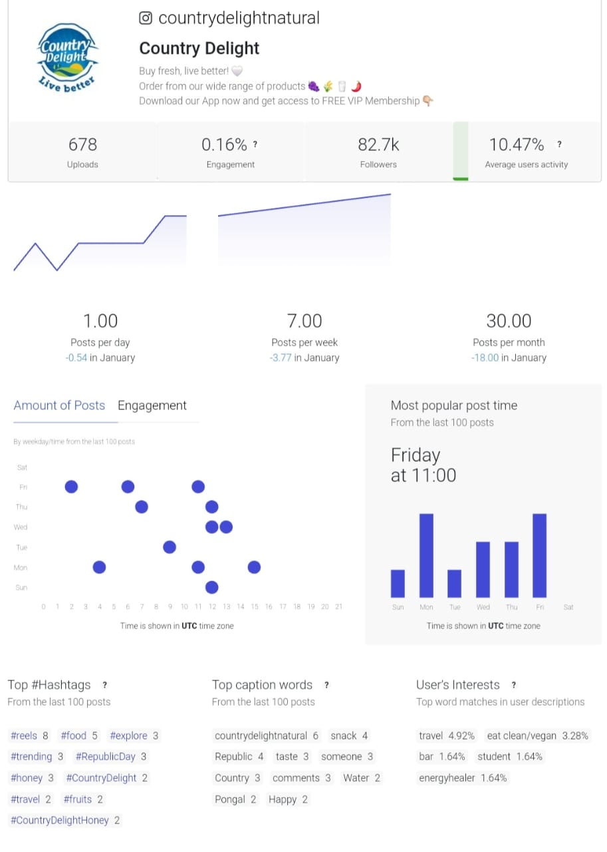

**COMPETITOR SOCIAL MEDIA ANALYSING-**

**BRAND NAME-** FARMERY

* **FOLLOWERS- 2.4K**
* **ENGAGEMENT- 0.18**
* **NUMBER OF POSTS- 706**
* **POST PER DAY- 1**

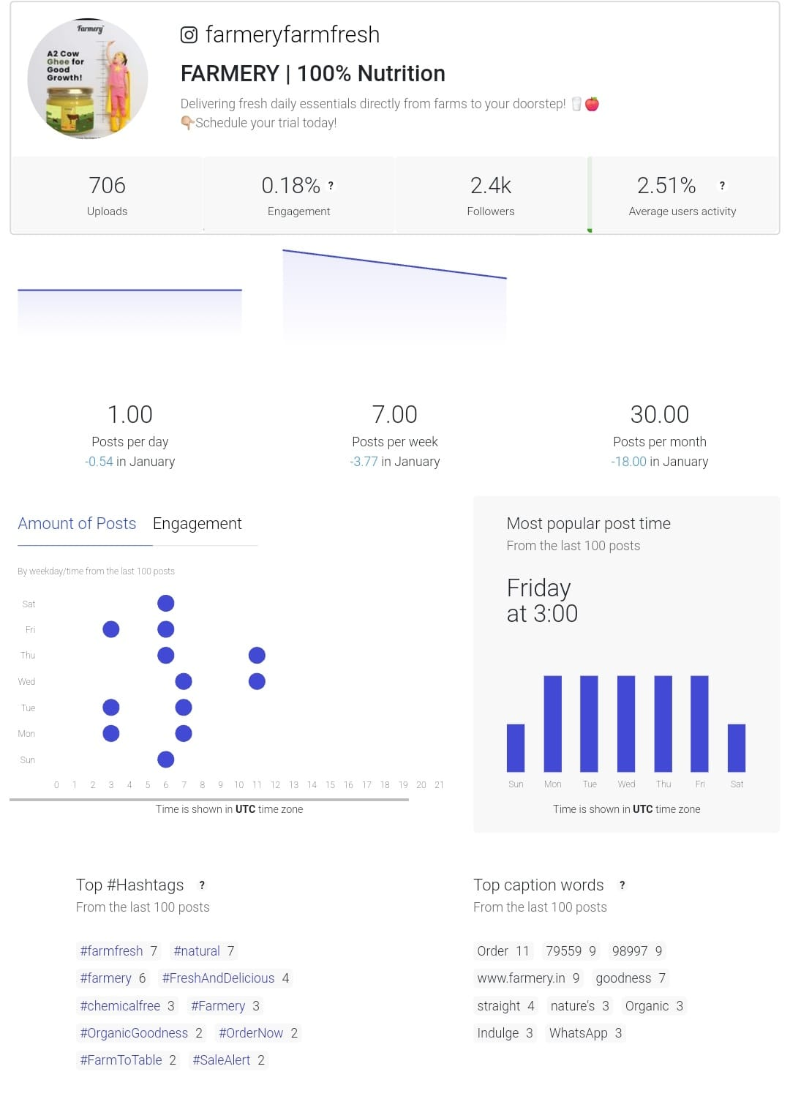

**OPPORTUNITIES FOR IMPROVEMENT- Country Delight should post more as they have less posts as compare to Farmery and they should also increase their engagement with the customers as they have less engagement rate than Farmery.**



**WOW SKIN SCIENCE SOCIAL MEDIA ANALYSING**

**TARGETED AUDIENCE- Natural, toxin-free skin, hair, and body care products are available at WOW Skin Science. WOW Skin Science's marketing plan is that it caters to internet-savvy Gen Z and millennials who are searching for reasonably priced and efficient beauty products12. With its kids line of products, the firm also caters to mothers and their children.**

**SOCIAL MEDIA PRESENCE-**

* **FOLLOWERS- 740K**
* **ENGAGEMENT- O.O2%**
* **NUMBER OF POSTS- 4.9K**
* **POST PER DAY- 1.50**

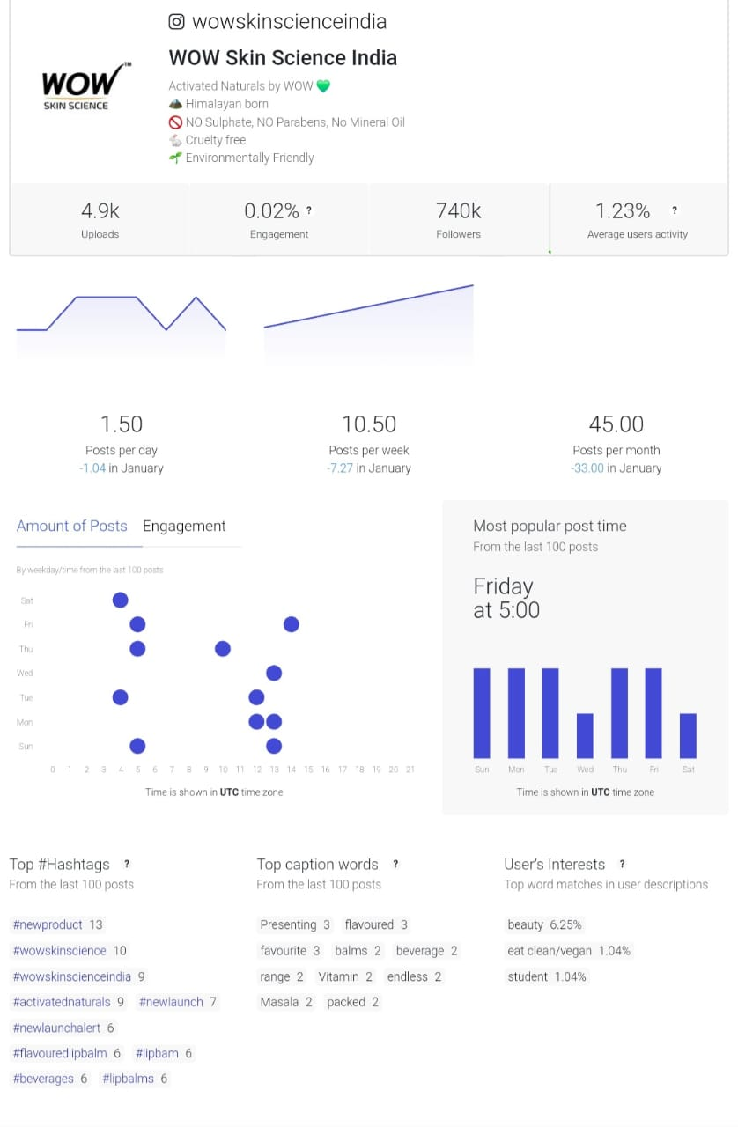

**COMPETITOR SOCIAL MEDIA ANALYSING-**

**BRAND NAME-** MAMAEARTH

* **FOLLOWERS- 1.3M**
* **ENGAGEMENT- 0.08%**
* **NUMBER OF POSTS- 4.2K**
* **POST PER DAY- 1.71**



**OPPORTUNITIES FOR IMPROVEMENT- - Wow skin science should post more as they have less posts as compare to Mamaearth and they should also increase their engagement with the customers as they have less engagement rate than Mamaearth.**

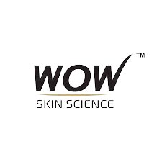

**TARGETED AUDIENCE- Reality TV actress and social media influencer Kylie Jenner founded the skincare line Kylie Skin Care. The company sells a variety of skin care items, including masks, serums, moisturizers, toners, and cleansers. Some sources claim that Gen Z and millennials that value natural, vegan, and cruelty-free goods are the primary target market for Kylie Skin Care.**

***KYLIE SKIN CARE SOCIAL MEDIA ANALYSING***

**SOCIAL MEDIA PRESENCE-**

* **FOLLOWERS- 5.8M**
* **ENGAGEMENT- 0.10%**
* **NUMBER OF POSTS- 285**
* **POST PER DAY- 0.92**

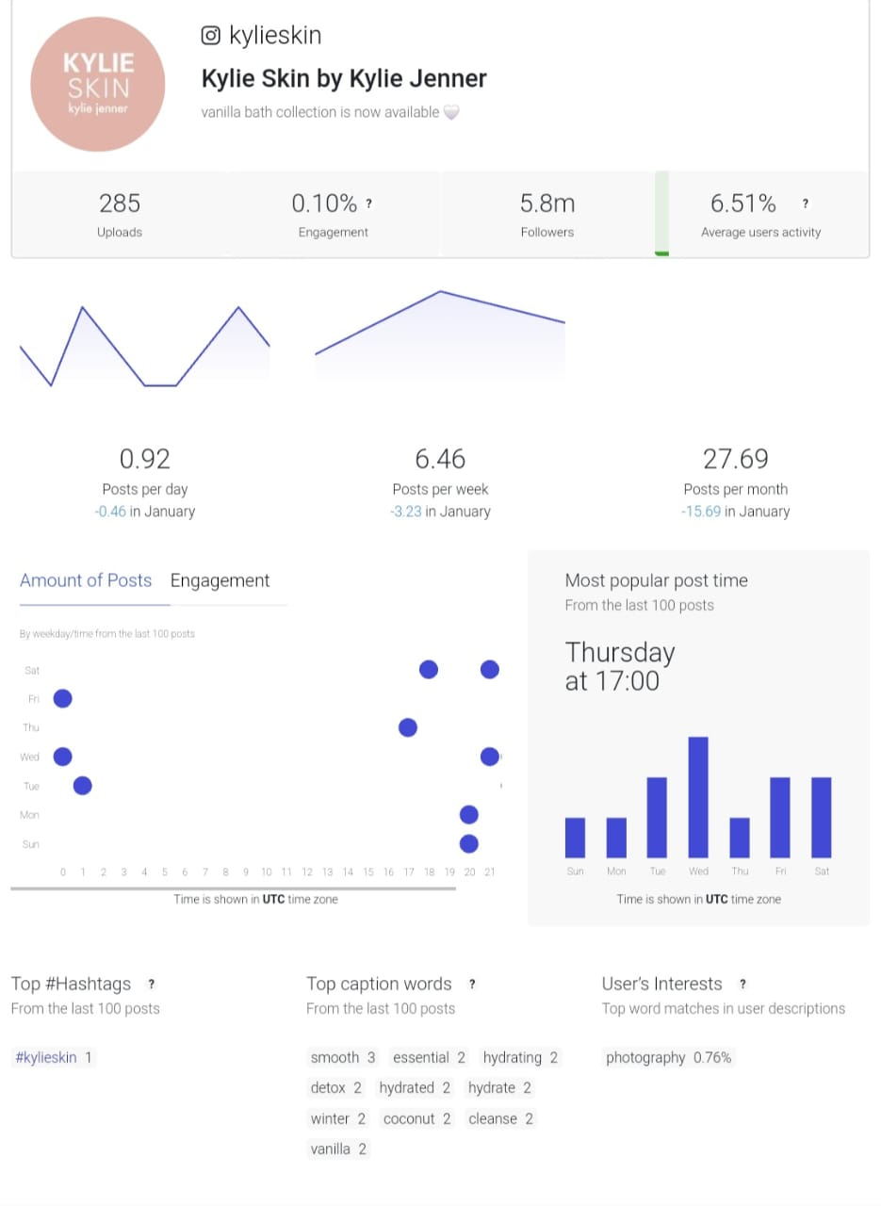**COMPETITOR SOCIAL MEDIA ANALYSING-**

**BRAND NAME-** ALLEYOOP

* **FOLLOWERS- 92K**
* **ENGAGEMENT- 0.06%**
* **NUMBER OF POSTS- 376**
* **POST PER DAY- 1**

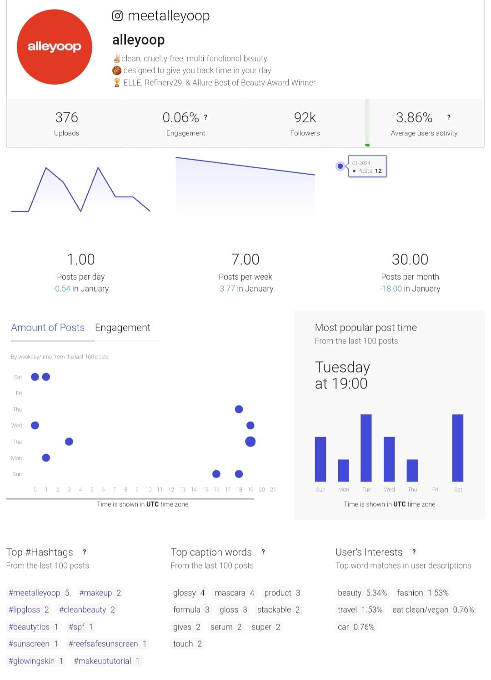

**OPPORTUNITIES FOR IMPROVEMENT- - Wow skin science should post more as they have less posts as compare to Mamaearth and they should also increase their engagement with the customers as they have less engagement rate than Mamaearth.**

